AMRITA VISHWA VIDYAPEETHAM
CHENNAI

Computer Science and Engineering (CSE)

DATA AND ANALYSIS OF ALGORITHMS

Roll No: CH.SC.U4CSE24112
Name: Deepak SN
Class: CSE-B
Year: 2024-2028
Data and Analysis of Algorithms
SPACE COMPLEXITY:
- Write a program to find sum of first n natural numbers, using user defined function.
Code:
//sum of n natural numbers
#include <stdio.h>
int n_sum(int n){
int sum=0,i;
for(i=1;i<=n;i++){
sum+=i;
}
printf("The sum: %d\n",sum);
return 0;
}
int main(){
int n;
printf("Enter the number to be stopped:");
scanf("%d",&n);
n_sum(n);
return 0;
}

Output:
Space complexity:
SP for int = 4+4+4 bytes
Space complexity= O(1) because all INT variables n,sum,i are fixed and not dynamic

- Write a program to find sum of squares of first n natural numbers.
Code:
//sum of squares of n natural numbers
#include <stdio.h>
int main(){
int n,sum=0,i;
printf("Enter the number to be stopped:");
scanf("%d",&n);
for(i=1;i<=n;i++){
sum+=(i*i);
}
printf("The sum: %d\n",sum);
return 0;
}
Output:
Space complexity:
SP of int=4+4+4
Space Complexity = O(1) because all INT variables n,sum,i are fixed and not dynamic
- Write a program to find sum of cubes of first n natural numbers.
Code:
//sum of cubes of n natural numbers
#include <stdio.h>
int main(){
int n,sum=0,i;
printf("Enter the number to be stopped:");
scanf("%d",&n);
for(i=1;i<=n;i++){
sum+=(i*i*i);
}
printf("The sum: %d\n",sum);
return 0;
}
Output:
Space complexity:
SP of int=4+4+4
Space Complexity = O(1) because all INT variables n,sum,i are fixed and not dynamic
- Write a program to find a factorial of the given integer using recursion.
Code:
//factorial using recursion
#include <stdio.h>
int fact(int n){
if(n==0){
return 1;
}else{
return n*fact(n-1);
}
}
int main(){
int n,sum=0,i;
printf("Enter the number to be stopped:");
scanf("%d",&n);
printf("The factorial of %d is: %d\n",n,fact(n));
return 0;
}
Output:
Space complexity:
SP of int=n*O(1)
Space Complexity = O(n) because all function fact(n) is going on recursively 'n' times
- Write a program for transposing a 3X3 matrix.
Code:
//transpose of 3x3 matrix
#include <stdio.h>
int main(){
int mat[3][3],tmat[3][3],i,j;
printf("Enter the values of matrix:\n");
for(i=0;i<3;i++){
for(j=0;j<3;j++){
scanf("%d",&mat[i][j]);
}
}
for(i=0;i<3;i++){
for(j=0;j<3;j++){
tmat[i][j]=mat[j][i];
}
}
printf("---------Normal Matrix----------\n");
for(i=0;i<3;i++){
for(j=0;j<3;j++){
printf("%d ",mat[i][j]);
}
printf("\n");
}
printf("---------Transposed Matrix----------\n");
for(i=0;i<3;i++){
for(j=0;j<3;j++){
printf("%d ",tmat[i][j]);
}
printf("\n");
}
return 0;
}
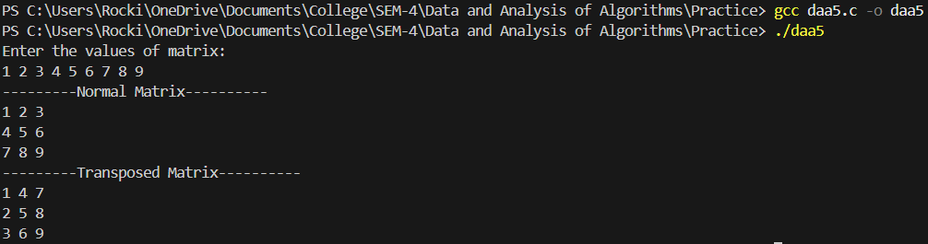
Output:
Space complexity:
SP of int=36+36+4+4
Space Complexity = O(1) because all INT variables mat,tmat,i,j are fixed and not dynamic
- Write a program to find fibonacci series.
Code:
//fibonacci series
#include <stdio.h>
int main(){
int a=0,b=1,c,n,i;
printf("Enter the number in series:");
scanf("%d",&n);
for(i=0;i<n;i++){
printf("%d ",a);
c=b;
b=a;
a+=c;
}
printf("\n");
return 0;
}
Output:
Space complexity:
SP of int=4+4+4+4+4
Space Complexity = O(1) because all INT variables a,b,c,n,i are fixed and not dynamic

